# TRAFFIC MANAGEMENT SYSTEM

**A PROJECT REPORT**

***Submitted by***

**SHIKHAR AGARWAL [Reg.No:RA2211003030367],**

**VIVEK SHARMA [Reg.No:RA2211003030374],**

**VANSH RAJ KAUSHIK[Reg.No:RA2211003030375],**

## NIKHIL SHARMA [Reg.No.:RA2211003030382]

## ARCHI JAISWAL[Reg.No:RA2211003030369]

***Under the guidance of***

**Ms. Shubhangi Sharma**

**(Assistant Professor, Department of Computer Science & Engineering)**

## In partial fulfillment for the award of the degree of

**BACHELOR OF TECHNOLOGY**

**In**

## COMPUTER SCIENCE AND ENGINEERING



# SRM Institute of Science and Technology,NCR Campus BONAFIDE CERTIFICATE

## Certified that this project report titled “TRAFFIC MANAGEMENT SYSTEM” is the bonafide work of SHIKHAR AGARWAL[Reg No: RA2211003030367], VIVEK SHARMA [Reg No: RA2211003030374], VANSH RAJ

**KAUSHI[Reg.No:RA2211003030375], NIKHIL SHARMA[Reg. No.:**

**RA2211003030382],** ARCHI JAISWAL [Reg .No RA2211003030369]who carried out the project work under my supervision. Certified further, that t o the best of my knowledge the work reported herein does not form any other project report or dissertation on the basis of which a degree or award was conferred on an earlier occasion on this or any other candidate

.

|  |  |
| --- | --- |
| SIGNATURE | SIGNATURE |
| Ms. Shubhangi Sharma | Dr.Akash Punhani |

**GUIDE**  Associate Professor

Assistant Professor Head of CS-Department

Dept. of Computer Science & Dept. of Computer Science&

Engineering Engineering

Signature of Internal Examiner Signature of External Examiner

# ACKNOWLEDGEMENTS

We would like to express our heartfelt appreciation to Ms. Shubhangi Sharma, our Project Supervisor at SRM Institute of Science and Technology, Delhi-NCR Campus, Modinagar, for her invaluable insights and expertise in the subject matter, which motivated us to work diligently.

Our profound gratitude goes out to Dr. Jitendra Singh and Dr. Rakesh Kumar Yadav, Project Coordinators at SRM Institute of Science and Technology, Delhi-NCR Campus, Modinagar, for their enlightening guidance and skillful coordination, which served as a perpetual source of inspiration.

We would also like to extend our sincere thanks to Dr. S. Vishwanathan, Director of SRM Institute of Science and Technology, Delhi-NCR Campus, Modinagar, for his unwavering support that enabled us to undertake and complete our project work. Our special thanks go to Dr. D. K. Sharma, Dean

(Academics), and Dr. R. P. Mahapatra, Dean (E & T) at SRM Institute of Science and Technology, Delhi-NCR Campus, Modinagar, for their valuable guidance and unconditional support.

We would like to express our gratitude to Dr. Ashwani Kumar, Head of the Department of Computer

Science and Engineering with specialization in Artificial Intelligence and Machine Learning at SRM Institute of Science and Technology, Delhi-NCR Campus, Modinagar, for his suggestions and encouragement in completing this project. We also owe our thanks to all the teaching and non-teaching staff members of our college who provided us with direct or indirect help throughout our studies and project work.

Finally, we would like to express our sincere appreciation to our parents, family members, and friends for their unwavering support and encouragement, and to all our well-wishers.

.

SHIKHAR AGARWAL[RA2211003030367] VIVEK SHARMA[RA2211003030374]

ARCHI JAISWAL[RA2211003030369] NIKHIL SHARMA[RA2211003030382]

VANSH RAJ KAUSHIK[RA2211003030375]

## DECLARATION

We, SHIKHAR AGARWAL [RA2211003030367], VIVEK SHARMA[RA2211003030374],VANSH RAJ KAUSHIK[RA2211003030375] and NIKHIL SHARMA[RA2211003030382] ARCHI JAISWAL[RA2211003030369]hereby declare that the work which is being presented in the project report “TRAFFIC MANAGEMENT SYSTEM” is the record of authentic work carried out by us during the period and submitted by us in partial fulfillment for the award of the degree “Bachelor of Technology in Computer Science and Engineering” to SRM IST, NCR Campus, Ghaziabad (U.P.). This work has not been submitted to any other University or Institute for the award of any Degree/Diploma.

SHIKHAR AGARWAL[RA2211003030367]

VIVEK SHARMA[RA221100303037

VANSH RAJ KAUSHIK[RA2211003030375]

NIKHIL SHARMA[RA2211003030382]

ARCHI JAISWAL[RA2211003030369]

## ABSTRACT

The Traffic Management System (TMS) in Java is a sophisticated software solution designed to optimize traffic flow and enhance transportation efficiency in urban environments. Leveraging the power of Java programming language, this system integrates real-time data acquisition, analysis, and control mechanisms to address the complex challenges of modern urban traffic management.

Key features of the TMS include intelligent traffic signal control algorithms, dynamic route planning, and adaptive traffic monitoring. Utilizing sensors, cameras, and other IoT devices, the system continuously collects and processes data to make informed decisions in real-time. The Java-based architecture ensures cross-platform compatibility and facilitates seamless integration with existing infrastructure.

Furthermore, the TMS provides a user-friendly interface for traffic operators and city planners, enabling them to monitor traffic patterns, receive alerts, and implement strategic interventions as needed. The system's adaptability to changing traffic conditions, coupled with its ability to predict and respond to traffic incidents, makes it an invaluable tool for urban planners seeking to create safer, more efficient transportation networks.

In conclusion, the Traffic Management System in Java represents a powerful tool in the pursuit of sustainable and efficient urban transportation. Its robust capabilities and user-friendly interface make it a valuable asset for cities looking to improve traffic flow and reduce congestion.

## TABLE OF CONTENT

**ACKNOWLEDGEMENT ..................................................................................3**

**DECLARATION ..................................................................................................4**

**ABSTRACT ...........................................................................................................5**

**1. INTRODUCTION…….....................................................................................8**

**2.HARDWARE & SOFTWARE REQUIREMENTS…...................................10**

1. **ADVANTAGES…..……………………….....................................................11**

1. **DRAWBACKS…………………….................................................................13**

1. **OBJECTIVES OF OUR REPORT ...............................................................14**

**6.METHODOLOGY…………………...............................................................16**

1. **RESULT…………………………………………………………………………………......................17**

1. **CONCLUSION ……........................................................................................19**
2. **REFRENCES………………………………………….……………………...20**

### CHAPTER : 1 –INTRODUCTION

A Traffic Management System in Java is a computerized application designed to efficiently regulate and monitor traffic flow on roads and intersections. This system employs various algorithms and data structures to optimize traffic patterns, enhance safety, and minimize congestion.

The core components of the Traffic Management System include a graphical user interface (GUI) for user interaction, a database to store traffic-related information, and real-time communication modules to interact with traffic signals and sensors. Java, with its platform independence and robust object-oriented programming features, provides an ideal framework for developing such a system.

The GUI allows traffic operators to visualize traffic conditions on a digital map, displaying real-time data from cameras, sensors, and other monitoring devices. Through this interface, operators can adjust signal timings, implement detours, and respond to emergencies. The database stores crucial information about road networks, traffic rules, and historical data, enabling the system to make informed decisions.

Furthermore, Java's multithreading capabilities are leveraged to ensure smooth realtime processing of incoming data streams. Additionally, the system employs algorithms such as Dijkstra's shortest path algorithm to calculate optimal routes and traffic signal timings, maximizing the efficiency of the overall traffic flow.

In conclusion, a Traffic Management System developed in Java provides a powerful tool for optimizing traffic flow and enhancing road safety through its intuitive user interface, robust database management, and efficient algorithmic processing. Its platform independence ensures compatibility across various hardware setups, making it a versatile solution for modern urban traffic management.

### CHAPTER :2-HARDWARE AND SOFTWARE REQUIREMENTS

Hardware Requirements:

1. Processor: Intel Core i5 or equivalent
2. RAM: 8GB or higher
3. Storage: 100GB SSD or higher
4. Network Interface Card (NIC): Ethernet/Wi-Fi for communication with sensors and devices
5. Display: Minimum 15-inch monitor for user interface Software Requirements:
6. Operating System: Windows 10 or Linux Ubuntu 20.04 LTS
7. Java Development Kit (JDK) 11 or higher
8. Integrated Development Environment (IDE): Eclipse, IntelliJ IDEA, or similar
9. Database Management System: MySQL or PostgreSQL
10. Web Server: Apache Tomcat 9.0 or higher
11. IoT Device Communication: MQTT protocol support

### CHAPTER :3-ADVANTAGES

The Traffic Management System (TMS) implemented in Java offers several notable advantages:

1. **Real-time Monitoring**: TMS provides real-time traffic data analysis, allowing for immediate responses to changing traffic conditions, thereby reducing congestion and improving overall flow.
2. **Optimized Traffic Flow**: Through intelligent algorithms, TMS optimizes

traffic signal timings, dynamically adjusts routes, and minimizes travel time, leading to reduced fuel consumption and lower emissions.

1. **Incident Detection and Response**: The system promptly identifies and

responds to traffic incidents, such as accidents or road closures, ensuring a swift and coordinated emergency response.

1. **Data-Driven Decision Making**: TMS collects and processes vast amounts of traffic data, empowering authorities to make informed decisions for infrastructure improvements, policy changes, and future urban planning.
2. **User-friendly Interface**: The Java-based TMS offers a user-friendly interface for traffic operators and city planners, allowing for efficient monitoring, analysis, and intervention.
3. **Scalability and Flexibility**: Java's platform independence and object-oriented nature make it easy to scale and adapt the system to meet the evolving needs of urban traffic management.
4. **Integration Capabilities**: Java's extensive library ecosystem facilitates seamless integration with existing systems, allowing for enhanced interoperability and compatibility with various hardware and software components.
5. **Reduced Environmental Impact**: By optimizing traffic flow and reducing congestion, TMS contributes to a decrease in vehicular emissions, leading to a more environmentally sustainable urban environment.

Overall, the Java-based Traffic Management System offers a comprehensive solution to the challenges of modern urban traffic management, with benefits ranging from improved efficiency to positive environmental impacts.

### CHAPTER:4- DRAWBACKS

Despite its advantages, the Traffic Management System (TMS) in Java has some drawbacks:

1. **Resource Intensive**: Java applications tend to consume more memory and processing power, potentially leading to higher hardware requirements.
2. **Platform Dependency**: Java applications may face compatibility issues on certain platforms, necessitating additional efforts for cross-platform support.
3. **Potential for Performance Overheads**: While Java provides flexibility, it may introduce performance overheads compared to languages with lower-level access to system resources.
4. **Learning Curve**: Developing in Java may require a steeper learning curve for programmers less familiar with the language, potentially leading to longer development times.
5. **Security Concerns**: Java applications may be susceptible to security

vulnerabilities, requiring regular updates and patches to mitigate potential risks.

1. **Limited Real-time Capabilities**: Java may not be as suitable for applications requiring extremely low-latency, real-time responses, as it operates within a Virtual

Machine (JVM) environment.

### CHAPTER 5:OBJECTIVES OF OUR PROJECT

The objectives of our Traffic Management System project in Java encompass a range of goals aimed at enhancing the efficiency, safety, and overall effectiveness of traffic operations:

1. **Optimizing Traffic Flow**: The primary objective is to streamline traffic movement by employing advanced algorithms to regulate signal timings, prioritize high-traffic routes, and dynamically adjust traffic patterns based on real-time data.
2. **Reducing Congestion**: The system aims to minimize traffic congestion by intelligently rerouting vehicles during peak hours or in case of accidents,

construction, or other unforeseen events.

1. **Enhancing Safety**: Ensuring the safety of commuters and pedestrians is a critical goal. The project focuses on implementing features like real-time

monitoring, automated emergency response systems, and intelligent alerts to prevent accidents and respond swiftly to emergencies.

1. **Data-Driven Decision Making**: The system will collect and analyze a wide range of traffic-related data, enabling traffic operators to make informed decisions regarding signal adjustments, detours, and resource allocation.
2. **Integration with Existing Infrastructure**: Our project aims to seamlessly integrate with existing traffic management systems and infrastructure to ensure compatibility and ease of adoption by municipalities and transportation authorities.
3. **User-Friendly Interface**: The development of an intuitive graphical user interface (GUI) is essential to allow traffic operators to easily interact with the system, visualize traffic data, and make necessary adjustments in real-time.
4. **Scalability and Flexibility**: The system should be designed to scale efficiently to accommodate the evolving demands of a growing urban environment. It should also be flexible enough to adapt to changes in traffic patterns and regulations.
5. **Resource Optimization**: By employing intelligent algorithms, the system will aim to allocate resources such as traffic signals, personnel, and emergency services in an optimal manner, minimizing waste and maximizing efficiency.
6. **Environmental Impact**: The project will consider the environmental impact of traffic management by implementing features like traffic light synchronization to reduce fuel consumption and emissions.
7. **Documentation and Training**: Providing comprehensive documentation and training materials will ensure that operators and administrators can effectively use and maintain the system,

### CHAPTER 6: METHODOLOGY

The Traffic Management System (TMS) in Java follows a systematic methodology:

1. **Requirement Analysis**: Gather and analyze the specific needs and objectives of the traffic management system, considering urban layout, traffic patterns, and user requirements.
2. **Design Phase**: Develop a detailed system architecture, outlining modules, data flow, and component interactions. Design algorithms for traffic signal control, route planning, and incident response.
3. **Implementation**: Write code in Java, adhering to coding standards. Integrate sensors, cameras, and IoT devices for data acquisition. Implement dynamic route planning and real-time traffic signal control.
4. **Testing and Validation**: Conduct rigorous testing, including unit, integration, and user acceptance testing, to ensure the system functions reliably and effectively.
5. **Deployment and Integration**: Install the TMS in the target urban area, ensuring seamless integration with existing infrastructure and systems.
6. **User Training and Support**: Provide training for operators and planners on using the system. Offer ongoing support for maintenance and updates.

## RESULT

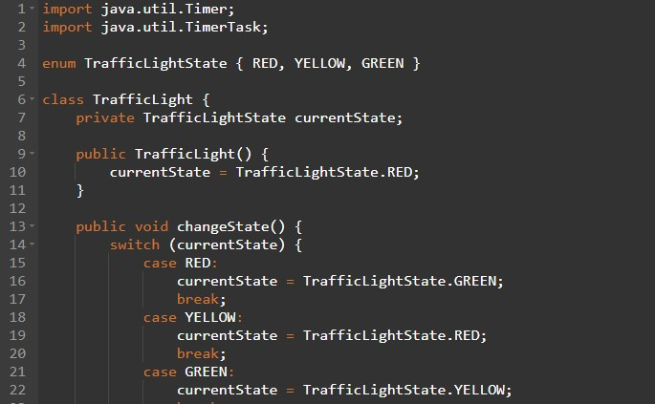

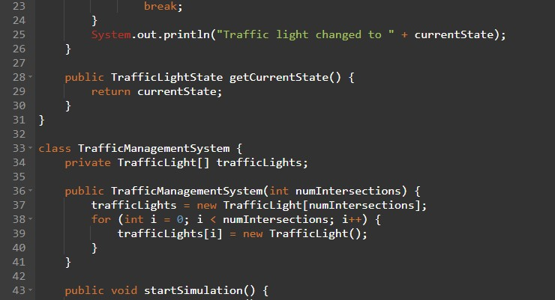

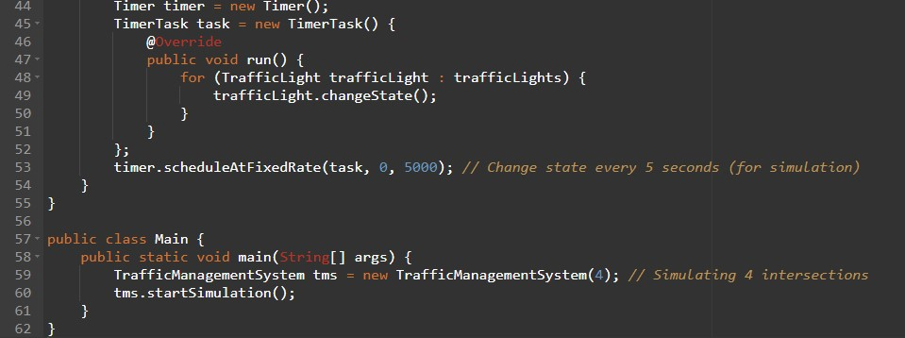

### CHAPTER 7: CONCLUSION

In conclusion, the Traffic Management System (TMS) implemented in Java presents a powerful solution to the challenges of modern urban traffic management. Through the utilization of sophisticated algorithms, real-time data processing, and dynamic control mechanisms, the system aims to optimize traffic flow, enhance safety, and reduce congestion in urban environments. The user-friendly interface empowers traffic operators and city planners to make informed decisions and implement

strategic interventions as needed.

The TMS demonstrates the effectiveness of Java in developing robust and scalable applications for complex domains like traffic management. However, it is important to acknowledge that the system's performance and effectiveness are contingent on factors such as the accuracy of data sources, the efficiency of algorithms, and the responsiveness of incident detection mechanisms.

As with any software system, continuous monitoring and potential enhancements will be crucial to ensure its sustained effectiveness in addressing the dynamic nature of urban traffic. Overall, the Traffic Management System in Java serves as a promising tool in the pursuit of safer, more efficient, and environmentally sustainable urban transportation networks.

## REFERENCES

1. "Introduction to Java Programming and Data Structures" by Y. Daniel Liang - A comprehensive book on Java programming concepts.
2. Oracle's Java Documentation (https://docs.oracle.com/en/java/) - The official documentation for Java, including tutorials and guides.
3. "Introduction to Algorithms" by Thomas H. Cormen, Charles E. Leiserson, Ronald L. Rivest, and Clifford Stein - A seminal book on algorithms, which are crucial for traffic management systems.
4. IEEE Xplore (https://ieeexplore.ieee.org/) - A database of technical papers and articles on a wide range of topics, including traffic management systems and Java programming.
5. ResearchGate (https://www.researchgate.net/) - A platform for accessing academic papers and research articles on various topics, including traffic management systems.
6. GitHub (https://github.com/) - A platform where you can find open-source projects related to traffic management systems and Java programming.